Speakers:

Nick John
Network Rail

and

Professor Roger Moore
CH2M

Date:
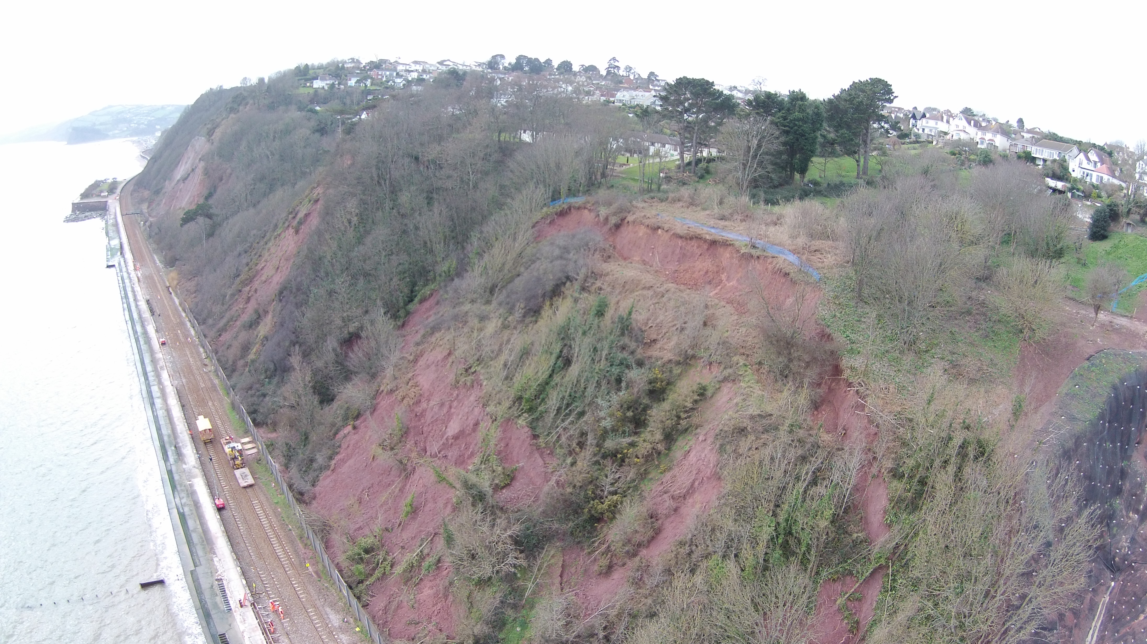
10th September 2015

Details:
Tea / coffee:
17:30

Meeting
Commences:
18:00
Location:
Burlington House

Free to attend
Registration not
required

For further information, please contact Event Convenor:
Ian Duncan
ian.duncan@mottmac.com

The Perfect Storm; improving railway resilience in extreme weather
An evening meeting of the Engineering Group of the
Geological Society

Network Rail provides strategic transport links throughout the UK. With an infrastructure that is typically more than 150 years old, the geotechnical assets are particularly vulnerable to extreme weather.

This talk presented by Nick John (Route Asset Manager - Geotechnical, Network Rail) and Roger Moore (Global Technology Leader, CH2M) provides an insight into railway asset resilience on the Western Route during the winters of 2012-14.

An unprecedented sequence of major storms led to coastal defence and geotechnical asset failures that closed the line for several months, with consequential disruption to services. The Teignmouth/Dawlish sea cliffs are used as a case study to provide details of Network Rail's approach to improving the asset resilience for Brunel's iconic coastal railway for the future.

Presentations by:
Nick John is a Chartered Geologist with 25 years’ experience within Geotechnical Consultancy and Asset Management. Nick learnt his trade with Hyder working on Welsh Water Projects which included tunnelling and general civils design before moving to Jacobs in 2004. For the last 5 years he has worked for Network Rail as an Asset Manager. He has recently taken up a position in the Wales Route as Asset Manager of Geotechnical, Drainage and Offtrack assets. Prior to this he was Route Asset Manager of the Geotechnical and Drainage Asset for Western Route and was instrumental in the restoration of the Geotechnical assets following the winters of 2012-14.

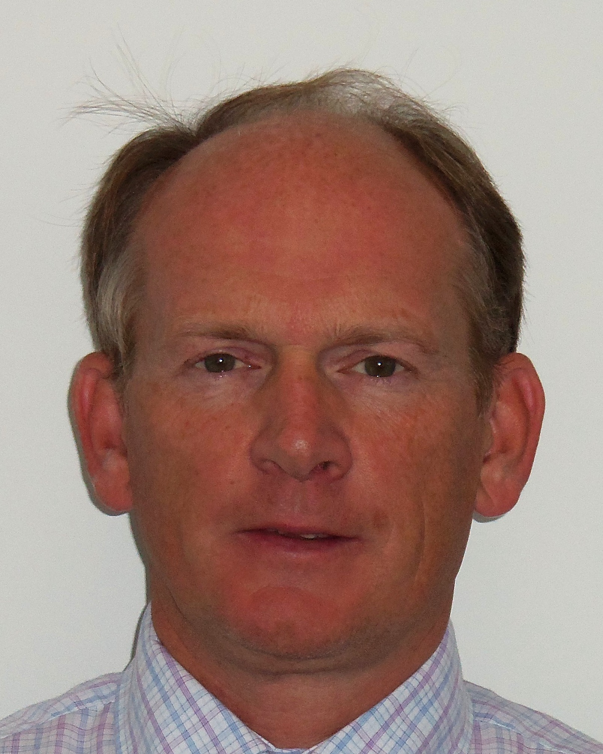
Professor Roger Moore is a UK Registered Ground Engineering Adviser, Chartered Geologist, Fellow of the Institution of Civil Engineers and Geological Society of London, and Fellow Technologist for Tunnels and Earth Engineering at CH2M based in Birmingham, UK. He is Professor of Applied Geomorphology at the University of Sussex, Brighton, and has over 30 years’ international experience in onshore and offshore geo-hazards and geotechnical engineering.
Roger has published 7 best practice guides, over 70 technical papers, and countless consultancy reports; his latest international good practice guide is on the subject of “Living with ground instability and landslides: understanding the risks, empowering communities, building resilience”.
Roger is an Expert advisor to Network Rail in connection with major land instability events at Chipping Campden and Dawlish.

